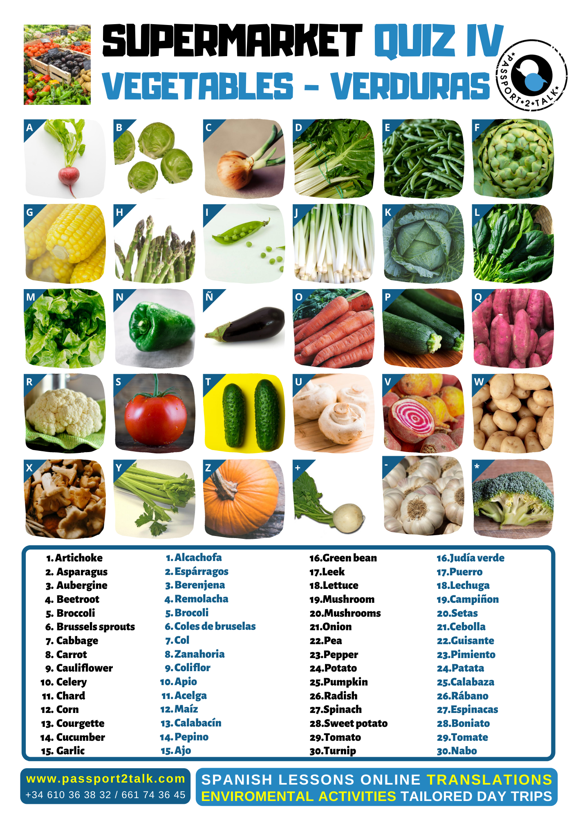

 | Key to QUIZ4 VEGETABLES | Solución a QUIZ4 VERDURAS
26 | Radish | Rábano
6 | Brussels sprouts | Coles de bruselas
21 | Onion | Cebolla
11 | Swiss Chard | Acelga
16 | Green bean | Judía verde
1 | Artichoke | Alcachofa
12 | Corn | Maíz
2 | Asparagus | Espárragos
22 | Pea | Guisante
17 | Leek | Puerro
7 | Cabbage, red cabbage | Col, col lombarda
27 | Spinach | Espinacas
17 | Lettuce | Lechuga
3 | Aubergine | Berenjena
23 | Green Pepper (red pepper, yellow pepper) | Pimiento verde, rojo, amarillo
8 | Carrot | Zanahoria
13 | Courgette | Calabacín
28 | Sweet potato | Boniato
9 | Cauliflower | Coliflor
29 | Tomato | Tomate
14 | Cucumber | Pepino
20 | Mushrooms | Setas
4 | Beetroot | Remolacha
24 | Potato | Patata
20 | Mushrooms | Setas
10 | Celery | Apio
25 | Pumpkin, butternut squash | Calabaza, calabaza cacahuete
30 | Turnip | Nabo
15 | Garlic | Ajo
5 | Broccoli | Brócoli

