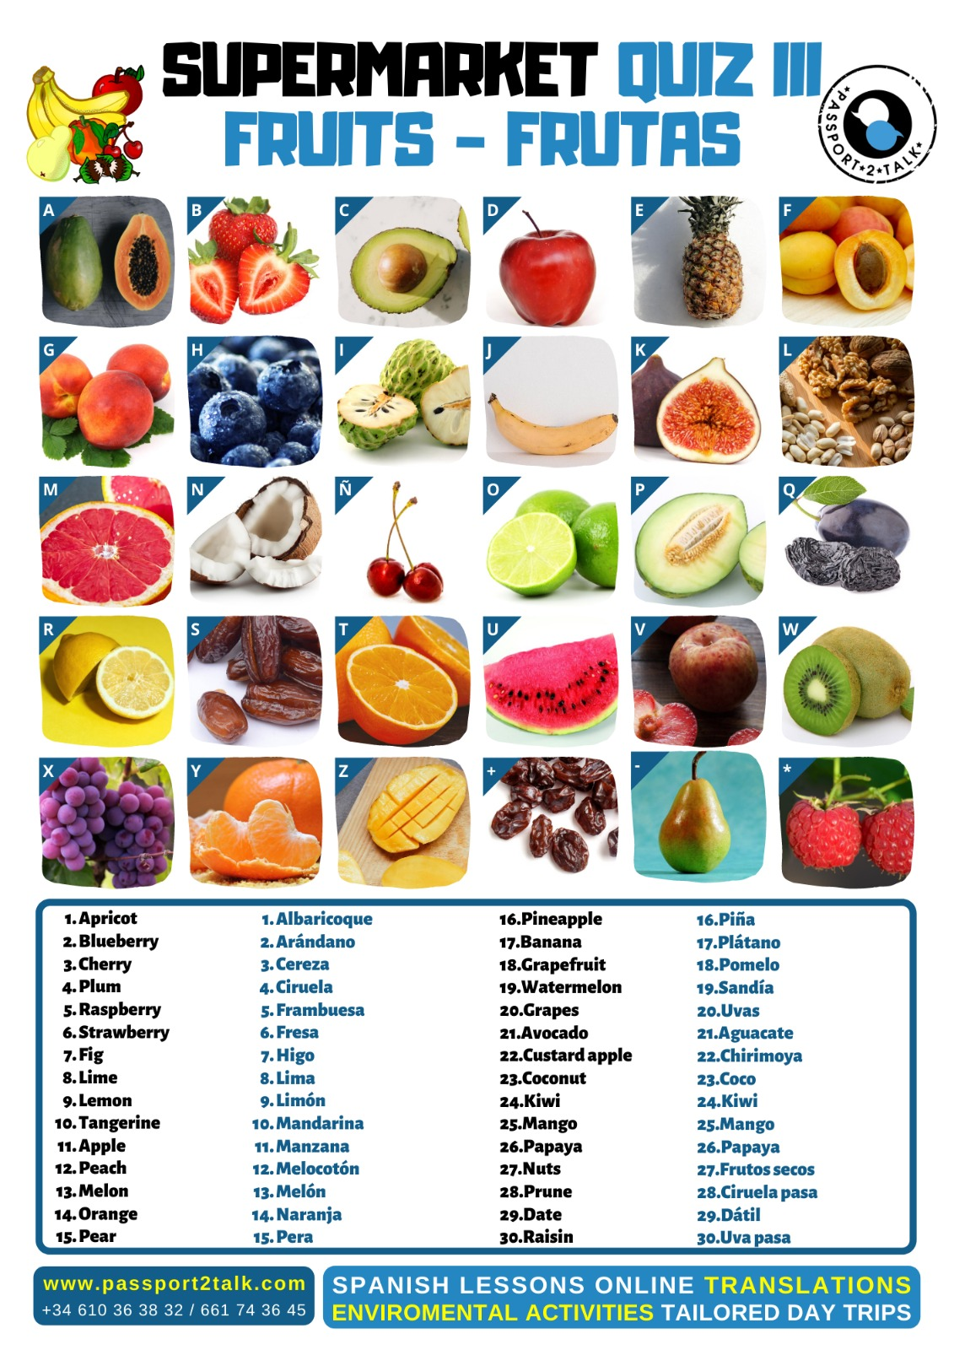

 | Key to QUIZ3 FRUITS | Solución a QUIZ3 FRUTAS
A26 | Papaya | Papaya
B6 | Strawberry | Fresa
C21 | Avocado | Aguacate
D11 | Apple | Manzana
E16 | Pineapple | Piña
F1 | Apricot | Albaricoque
G12 | Peach | Melocotón
H2 | Blueberry | Arándano
I22 | Custard apple | Chirimoya
J17 | Banana | Plátano
K7 | Fig | Higo
L27 | Nuts | Frutos secos
M18 | Grapefruit | Pomelo
N23 | Coconut | Coco
Ñ3 | Cherry | Cereza
O8 | Lime | Lima
P13 | Melon | Melón
Q28 | Prune | Ciruela pasa
R9 | Lemon | Limón
S29 | Date | Dátil
T14 | Orange | Naranja
U19 | Watermelon | Sandía
V4 | Plum | Ciruela
W24 | Kiwi | Kiwi
X20 | Grapes | Uvas
Y10 | Tangerine, mandarin | Mandarina
Z25 | Mango | Mango
`+30 | Raisin | Uva pasa
`-15 | Pear | Pera
`*5 | Raspberry | Frambuesa

